TITLE

Author^{1*} – Author ² – Author ¹
¹Affilation
² Affilation
*e-mail address (only corresponding author)

Abstract
Text… Text … Text … Text … Text … Text … Text … Text … Text … Text … Text … Text … Text … Text … Text … Text … Text … Text … Text … Text … (Max. 300 word)

Keywords: (Max. 5-8)

Introduction
Text… Text… Text… Text… Text… Text… Text… Text… Text… Text… Text… Text… Text… Text… Text… Text… Text… Text… (Deo and Samui, 2017; Adnan et al., 2020).

Material and method
Text… Text… Text… Text… Text… Text… Text… Text… Text… Text… Text… Text… Text… Text… Text… Text… Text… Text…
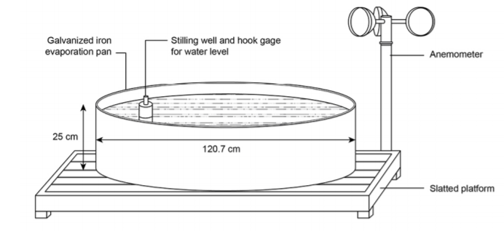
Figure 1 Illustration of a standard Class A pan (Alsumaiei, 2020)

Text… Text… Text… Text… Text… Text… Text… Text… Text… Text… Text… Text… Text… Text… Text… Text… Text… Text…

Results
Subtitle
Text… Text… Text… Text… Text… Text… Text… Text… Text… Text… Text… Text… Text… Text… Text… Text… Text… Text… Text… Text…

Table 1 Multiple stepwise regression analysis between meteorological elements and measured Class A pan evaporation: "empty" pan (C), pan with sediment (S) and pan with macrophyte (SM) during 2020 growing season
 | R² | F | F sig. | SE | Regression equation
C
Model 1 | 0.484 | 96.76 | 0.000 | Konst. = 0.251  Rs = 0.011 | E_{p} = 0.111Rs + 0.796
Model 2 | 0.552 | 62.73 | 0.000 | Konst. = 0.937  Rs = 0.013  RH = 0.01 | E_{p} = 0.06Rs ­ 0.039RH + 4.34
S
Model 1 | 0.511 | 107.74 | 0.000 | Konst. = 0.250  Rs = 0.011 | E_{p} = 0.116Rs + 0.892
Model 2 | 0.571 | 67.89 | 0.000 | Konst. = 0.938  Rs = 0.013  RH = 0.01 | E_{p} = 0.087Rs ­ 0.038RH + 4.315
SM
Model 1 | 0.585 | 154.46 | 0.000 | Konst. = 0.247  Rs = 0.011 | E_{p} = 0.133Rs + 0.777
Model 2 | 0.654 | 96.44 | 0.000 | Konst. = 0.903  Rs = 0.014  RH = 0.01 | E_{p} = 0.099Rs ­ 0.043RH + 4.711

Text… Text… Text… Text… Text… Text…

Discussion
Text… Text… Text… Text… Text… Text… Text… Text… Text… Text… Text… Text…
Text… Text… Text… Text… Text… Text… Text… Text… Text… Text… Text… Text…

Acknowledgement
Text… Text… Text… Text… Text… Text… Text… Text… Text… Text… Text… Text…
Text… Text… Text… Text… Text… Text… Text… Text… Text…

References
Journal paper (please delete it)
Bauer, P.J., Frederick, R.J., Bradow, E.J., Sadler, E.J. and Evans, D.E. 2000. Canopy photosynthesis and fiber properties of normal- and late-planted cotton. Agronomy Journal. 92. 518-523.
Anda, A. Simon, B., Soós, G. and Kucserka, T. 2018. Estimation of natural water body’s evaporation based on Class A pan measurements in comparison to reference evapotranspiration. Időjárás. 122(1). 41–58.
Books (please delete it)
Storch, H. von. and Flöser, G. 2000. Models in Environmental Research. Springer-Verlag, Berlin/Heidelberg, 152-158.
Proceedings volume (please delete it)
Cagirgan, M.J., and C. Toker. 1996. Pathcoefficient analysis for grain yield and related characters under semiarid conditions in barley. p: 607-609. In A. Slinkard et al. (ed) Proc. Int. Oat Conf., 5th Int. Barley Genet. Symp., 7th Vol. 2. Univ. of Saskatchewan Ext. Press, Saskatoon, Canada.

